Table of Contents
Section 4. REDCap Mobile App 1
4.1 Logging into the REDCap Mobile App 1
4.2 Security Best Practices 1
4.3 Entering Data into the REDCap Mobile App 2
4.4 Sending Data to the Server (i.e., data upload) 3
4.5 Logging Out 4
4.6 Creating Additional Data Collector User Accounts on the Device 4
4.7 Connecting a Data Collector User to the REDCap Project 4
4.7 Data Collector User Management 5

Section 4. REDCap Mobile App

REDCap is a mature, secure web application for building and managing online surveys and databases. The REDCap Mobile App is used to collect data in places where internet connections are unreliable or non-existent.

4.1 Logging into the REDCap Mobile App

In order to use the REDCap Mobile App, an admin user must have setup the device and added a user account for you. They will need to tell you your user name and PIN (personal identification number). The PIN is not the same as the device unlock code. To begin a data collection session, you will first login by following these steps:

1. At the login screen, select your user name from the dropdown list of users.
2. Enter your 6-digit PIN number.
3. Press the Login button to login to the app.

If you have trouble logging in to the device, you will need to contact your site’s administrator.

4.2 Security Best Practices

In order to protect the privacy or people completing the REDCap CRFs, it is important to practice good device and app security. Follow these steps to protect the privacy of everyone:

- Keep your PIN secret. Do not write it down.
- When you are done with collecting data or are taking a break, log out of the REDCap Mobile App. If necessary, press the “<” arrow at upper right of the screen until you see the word Logout and then press on it to log completely out. Finally close the REDCap App.
- If you believe someone else knows your PIN, then change your PIN by logging into the REDCap Mobile App and pressing “Change My Password” at the home screen.
- When you are done entering a batch of CRFs and have Internet connectivity, click “Send Data to Server” to securely end the records to the server and remove them from the device (see later section entitled “Sending Data to the Server”).

4.3 Entering Data into the REDCap Mobile App

Follow these steps to enter new records:

- After logging on, press “My Projects” to select the project.
- Press the button containing the name of the project to open that project (e.g., “MTN-042B”).
- Press “Collect Data” to enter records.
- The App will present you with a list of instruments for the project (e.g., “MTN-042B”). Note that the MTN-04B project only has one form with the same name as the project.
- Click Create New Record to enter a new CRF.
- There will be delay while the CRF is rendered.
- Enter data into the fields on the CRF.
- When you save the data, you will be informed of any required fields that have not been completed. Press “Stay on Page” to return to the CRF and complete the required fields or “Save and leave record” to save the record in an incomplete state. The REDCap Mobile App may take a minute to save the record. Please be patient.
Follow these steps to review or edit existing records:

- After logging on, press “My Projects” to select the project.
- Press the button containing the name of the project to open that project (e.g., “MTN-042B”).
- If the records being reviewed or edited were collected by the same user on the same mobile device and has not yet been uploaded to the server, skip to step 7.
- If records being reviewed or edited have been entered by another user on a different mobile device or entered directly into REDCap using a web browser on a computer, you must ensure all data collected on the mobile device has been sent to the REDCap server before moving to step 5. This will be indicated at the top of the screen, under the project name, by “Records (0 new; 0 modified)”.
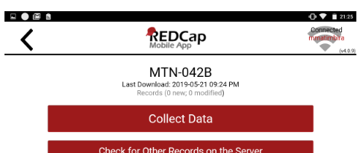

If there are any new or modified records, do not proceed to step 5 and refer to the “Sending Data to the Server” section below. This is very important to prevent loss of data.
- After confirming all data on the tablet has been sent to the server, you can download existing records by pressing “Refresh setup and data”. A dialog box will appear and ask if you want to proceed. Select “Proceed” ONLY if you have confirmed that all data on the mobile device has been uploaded to the server. A second dialog box will appear and ask if you are sure you want to proceed. Select “Proceed” ONLY if you have confirmed that all data on the mobile device has been uploaded to the server.
- When you proceed you will be asked if you want to download all records from the project or if you want to download a partial set of records. Ideally you will download a selection of records as downloading all records may take a long time.
  - If performing QC step #2, press “Download by Form Status”, select Status: “Unverified”, and press “Download Filtered Forms”.
  - If updating forms that were incomplete, press “Download by Form Status”, select Status: “Incomplete”, and press “Download Filtered Forms”.
  - If reviewing or editing specific records, press “Get a Partial Set of Data”, select the records you want to download, and press “Download Checked Records”
- Press “Collect Data”.
- The App will present you with a list of instruments for the project (e.g., “MTN-042B”). Note that the MTN-04B project only has one form with the same name as the project.
- Select the PTID you want to review or edit to return to that record.
- There will be delay while the CRF is rendered.
- Enter data into the fields on the CRF.
- When you save the data, you will be informed of any required fields that have not been completed. Press “Stay on Page” to return to the CRF and complete the required fields or “Save and leave record” to save the record in an incomplete state. The REDCap Mobile If the data is not available, and it will not become available, the staff member can select “Save and leave record” to save the form without the required data.

4.4 Sending Data to the Server (i.e., data upload)

NOTE: To prevent loss of data, data should be sent to the server, at a minimum, once at the end of each day and always prior to downloading data from the server to a tablet.

Under each instrument of a project, the REDCap Mobile App will list any records that have been collected. REDCap will display the record number, the name of the Institution and whether the record is complete, incomplete, or unverified. At the end of each day, and prior to downloading any data from the server, you will want to send those records to the REDCap server in Seattle. Internet connectivity will be needed to send data to the server.
To do this, back out to the project screen by clicking on the “<” arrow at the top left corner of the screen. When you are at the correct screen, you will see the “Collect Data”, “Send Data to Server”, and several other buttons. From this screen, follow these steps to send data to the server:
- Press “Send Data to Server”.
- You are ready to send the data. Press “Begin Send of All Data” to send all records.
- If you are updating existing records, a warning dialog will indicate that some of the new records you are trying to upload already exist on the server. If this is unexpected (i.e., you are only uploading new records), press “Rename Records” to view the records that already exist on the server. Press “Upload Anyway” to update the existing records.
- When the sync is complete, click on the Options button.
- At the Available Options menu, press…
  - Return to Project to continue.
  - Refresh Setup & Data if the REDCap project has recently changed, and you need to download the changes and/or to refresh the records on the device. This will require two confirmations.
  - Open Sync report if you wish to review the sync report. You will want to select this option if any errors are reported during the sync.

4.5 Logging Out

When you are done with collecting data or are taking a break, log out of the REDCap Mobile App. If necessary, press the “<” arrow at upper right of the screen until you see the word Logout and then press on it to log completely out. Finally close the REDCap App.

4.6 Creating Additional Data Collector User Accounts on the Device

If you want to set up more data collector user accounts on the device, the site REDCap Mobile admin user should log into the Admin account on the device, and click “Add New User.”

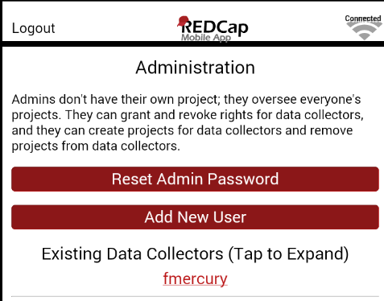

4.7 Connecting a Data Collector User to the REDCap Project

Please note that you must have internet connectivity to set up a project on the mobile device. Follow these steps to authorize the user for a project:

- From the REDCap Mobile app on the device: If not already created, create the user (see the prior section) using the Admin user and logout.
- Log in to the REDCap Mobile App as the Admin.
- Tap the name of the existing data collector user who you wish to authorize.
- Scroll down. Under Functions for User xxx, you will see a button “Set Up New Mobile Project”.
- Press the “Set Up New Mobile Project” button. The system brings up the “Initialize a Project” screen and offers two different methods:
  - Scan QR code
  - Initialization code
- From the computer: For either of these methods, the next step is to log into REDCap using a browser on a PC or laptop computer that is connected to the Internet. There, you must log in as one of the following users:
- Blantyre_User
- MUJHU_User
- WRHI_User
- Zengeza_User
- From the computer: The password will be communicated to you securely. (Do not write it down in this guide.)
- From the computer: At the REDCap Home screen, click on the My Projects tab.
- From the computer: Click on the project you wish to setup under My Projects to open that project.
- From the computer: Click on “REDCap Mobile App” in the left panel of the screen.
- From the computer: The Set Up Project in Mobile App tab should be displayed. If not, click on the tab.
- From the computer: Under Step 2, REDCap will display a square pattern called a QR code. At this point you can press “Scan QR Code” on the mobile device and use the camera to capture the image. Once the QR code is captured, you will be prompted to “Approve QR Results” by clicking on a button with the intended project name.
- Note: if your device doesn’t have a camera or you can’t get it to scan the code, click “Can’t get the QR code to work?” to use the alternative method which will provide you will an Initialization code which you can type into the REDCap Mobile App instead.
- Repeat steps 1-13 for each data collector user.

4.7 Data Collector User Management

In order to manage users on the device, you will need to login as the Admin user. From here, you can:
- Add users (see earlier section)
- View a list of existing users
- Reset the Admin Password (PIN)
- Reset a user’s password
- Remove users
It is important to keep the Admin PIN secure and remove users from the device if they no longer work at the project. It is also important to securely communicate PINs to users and instruct them in staying secure. See the section “Security Best Practices”.

