MTN-037 Study Adherence Guidelines
Following all study instructions and requirements is important to ensure your safety as a participant and the validity of the study. Please review this document carefully and keep available for reference at home.
- Attend all Study Visits as Scheduled
It is important for you to come to every study visit. If you cannot come to the visit, please tell the study staff as soon as possible so that the visit can be rescheduled.
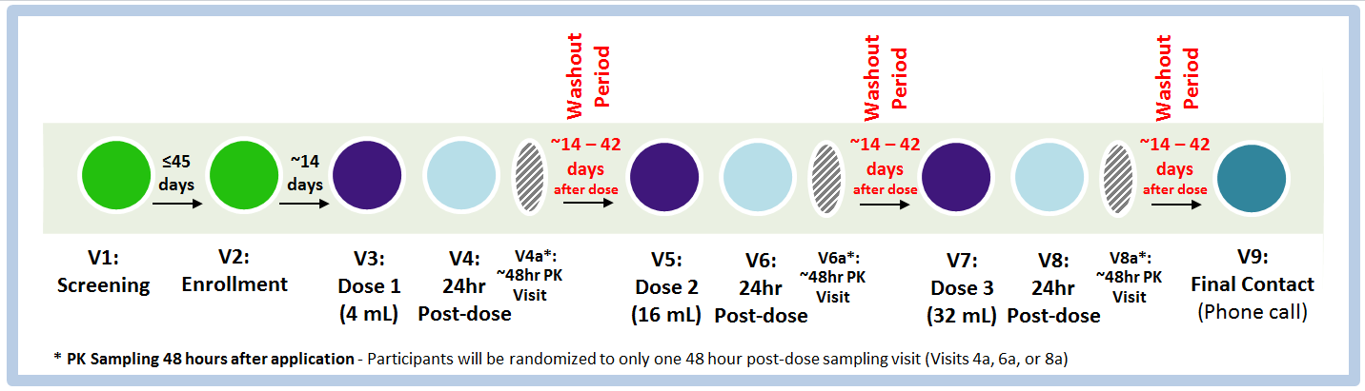

- Refrain/abstain from certain activities during specified periods of time, as follows:
 | Entire duration of Study | 72 hrs prior to study visits (V2-8a) | 72 hrs after study visits (V2-8a)
Medications*
Rectally-administered products and products containing N-9 | x
CYP3A inhibitors and inducers | x
Anticoagulants or blood thinners (such as heparin, Lovenox®, warfarin, Plavix® [clopidogrel bisulfate) | x
Pre-exposure prophylaxis (PrEP) and post-exposure prophylaxis (PEP) | x
Taking Aspirin (greater than 81 mg) |  | x | x
Non-steroidal anti-inflammatory drugs (NSAIDS) |  | x | x
Any other medications that could increase bleeding |  | x | x
Sexual Practices
Inserting any non-study products (including sex toys into the rectum) |  | x | x
Receptive anal intercourse (RAI) |  | x | x
Rectal stimulation via fingers |  | x | x
Receptive oral anogenital stimulation |  |  | x
FOR FEMALES:  Receptive penile-vaginal intercourse or inserting anything in the vagina including:  - spermicides,  - vaginal medications (including hormones)  - vaginal douches,  - lubricants and moisturizers,  - sex toys (vibrators, dildos, etc.) |  | x
*Let the clinic know if you start taking any medication so they can check to make sure the study products will not interfere with how your medication works.
- Use an effective contraceptive method (FOR FEMALES)
Female participants must use an effective contraceptive method for the entire duration of the study. Effective methods include sterilization, hormonal methods (expect vaginal rings), IUDs, and having sex only with women.

If you have any questions or concerns about the study adherence guidelines, contact the following study staff:<Study Staff contact info>

